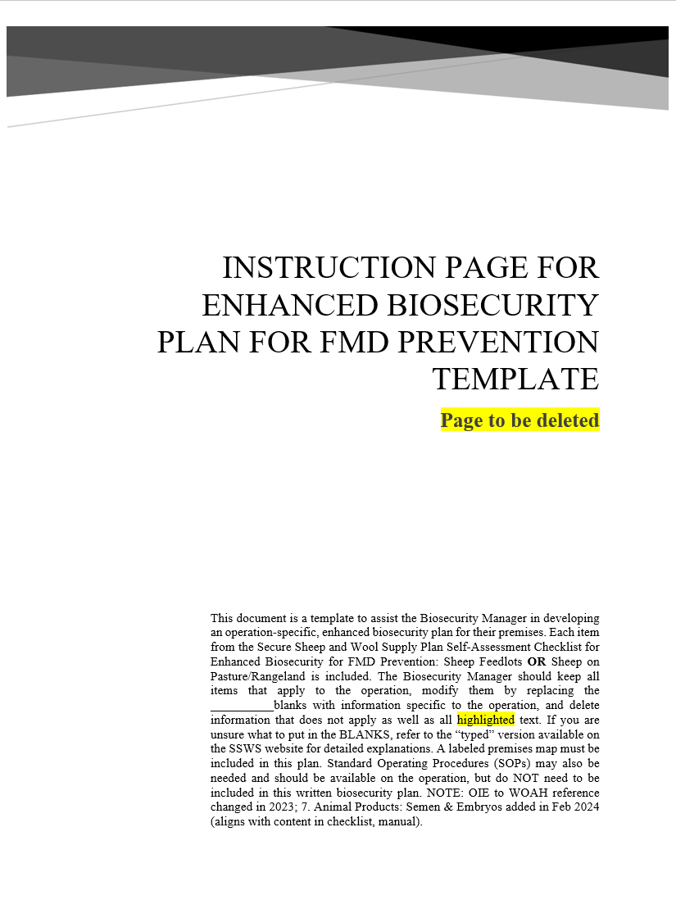_____________Enhanced Biosecurity Plan for FMD Prevention in _______________
Date [created or updated]: ________________________________
This Enhanced Biosecurity Plan is based on the Secure Sheep and Wool Supply (SSWS) Plan Self-Assessment Checklist for Enhanced Biosecurity, ___________________________ and was developed using guidance from the SSWS Information Manual for Enhanced Biosecurity for FMD Prevention:___________________________. All documents are available at www.securesheepwool.org. In the plan below, all items are implemented unless marked except those indicated which will be implemented prior to requesting an animal movement permit.

Scope of Biosecurity Plan
Describe the Premises:
- National Premises Identification Number (Prem ID or PIN): ____________________(request from the office of the State Animal Health Official)
- Premises Address: ______________________________________________________________
- Premises GPS Coordinates: _______________________________________________________
- Animals* on primary premises: ____________________________________________________
______________________________________________________________________________Animal housing types: ___________________________________________________________
______________________________________________________________________________Other business operations on premises? __________If yes, what? _________________________
- Secondary premises** locations: (PINs, 911 addresses, or GPS coordinates):
  - Will be provided if this premises is located in an FMD Control Area
  - ______________________________________________________________________

*Animals that are susceptible to FMD include cattle, pigs, sheep and goats. For biosecurity guidance for beef cattle, dairy cattle, and pigs, see www.securebeef.org, www.securemilksupply.org, and www.securepork.org.
**Work with your State Animal Health Official to determine if separate PINs are needed for all of your associated premises.

Biosecurity Manager and Written Plan
The designated Biosecurity Manager for this premises and their contact information is:
NAME: ______________________________________________
PHONE: _____________________________________________
EMAIL: _____________________________________________
In the event the Biosecurity Manager is away from the operation, their designee’s contact information is:
NAME: _____________________________________________
PHONE: ____________________________________________
EMAIL: ____________________________________________
The Biosecurity Manager’s contact information is posted ______________________________________.
_________________________________ and ___________________________________ have the written authority to ensure compliance with biosecurity protocols and take corrective action as needed.
______________________________________developed the operation-specific biosecurity plan with the assistance of (keep all that apply):
_________________________________, a _______________________________ whose contact information is:
PHONE: ___________________________________________
EMAIL: ___________________________________________
_____________________________, a consultant with ___________________________ ______ whose contact information is:
PHONE: _________________________________
EMAIL: _________________________________
The Biosecurity Manager or their designee (check all that apply):
☐ communicates with and/or trains individuals entering the premises on biosecurity measures to follow;
☐ reviews the biosecurity plan at least annually and updates it whenever the operation goes through a change affecting biosecurity;
☐ ensures that all individuals entering the operation frequently (weekly or more often) have access to a copy of the biosecurity plan; and
☐ is capable of implementing the written plan if FMD is diagnosed in the U.S.
A labeled premises map is included at the end of this plan and can be found on the premises at: ________
_______________________________________________________.

Training
The people listed below are trained at least ___________________________ about the biosecurity measures necessary to keep FMD out of the herd. This training is documented and available for review upon request.
- ____________________________________
- ____________________________________
- ____________________________________
The Biosecurity Manager(s) informs individuals entering the premises of the biosecurity measures they are to follow in a language they understand. Individuals are aware of the biosecurity concepts and procedures that apply to their specific areas of responsibility. Our required training is described below.
All individuals entering must understand how to
☐ Contact the Biosecurity Manager(s)
☐ Respect the Line of Separation (LOS)
☐ Cross the LOS, if required, following arrival and biosecure entry requirements
☐ Perform biosecurity measures for their specific job duties
Essential personnel must also:
☐ Understand the importance of biosecurity;
☐ Review the entire biosecurity plan;
☐ Review the labeled premises map;
☐ Know who to report to if they see someone not complying or something preventing compliance; and
☐ Recognize the consequences for not complying with biosecurity protocols.

Protecting the Flock

Line of Separation (LOS)
The Line of Separation is labeled on the premises map at the end of this plan. The LOS is marked on-site with _______________________________________________________________________________.
Sheep do not have access to other livestock, streams, waterways, or run-off water or organic matter that may have come from other premises.

Maximize Distance between Susceptible Livestock on Adjacent Premises
(From Sheep on Pasture/Rangeland – delete what does not apply)
The distance is maximized between susceptible livestock on adjacent premises, and steps to do so have been coordinated with owners/operators of these premises. Those steps include: __________________
__________________________________________________________________________________.

LOS Access Point(s)
Entry to the operation is restricted to ______ controlled LOS Access Point(s) and each are labeled on the premises map at the end of this plan. The LOS Access Points are clearly marked with a suitable barrier of _______________________________________________________________________ to restrict entry. Unused driveways that are not LOS Access Points are protected with ____________________________________________________________________________________ to prevent vehicles and people from entering.
Signs written in ________________________________________________ are posted at all LOS Access Points that include:____________________________________________________________________.
All movements (animals, vehicles, equipment, people) across the LOS are recorded and these documents are kept in the _____________________________________ and are available for review upon request.
The animal load-out/load-in area(s) is/are labeled on the premises map at the end of this plan and this area is NOT used for a people entry point.
Deliveries not essential to the operation are made outside of the LOS at the ________________________ and this area is indicated on the premises map and signage is posted at the LOS Access Point.
Vehicles crossing through the LOS Access Points are cleaned to remove visible contamination and then disinfected at the Cleaning and Disinfection Station.
People and items crossing through the LOS Access Points follow appropriate specific biosecurity steps, described under Biosecure Entry Procedure in this plan.

Cleaning and Disinfection (C&D) Station
There is an operational, clearly marked, and equipped C&D station(s) located ______________________
____________________________________________________________________________________ and it is labeled on the premises map at the end of this plan. The wash pad for the C&D station is made of _____________________________________________________________ and slopes away from animal housing, feed receiving or storage areas, waterways, and on-farm traffic areas. This operation uses _____________________________________________________ to manage effluent from the C&D area to ensure susceptible animals are not exposed. Effluent from the C&D Station is managed following all state and local regulations.
This operation has access to all the equipment and supplies needed to successfully operate the C&D Station. The SOP for the C&D process is available upon request.
The following individuals have received documented training in proper selection and use of personal protective equipment, the principles of C&D to avoid introducing FMD virus to the operation, and area able to effectively operate the C&D Station:
- _________________________________________
- _________________________________________
- _________________________________________
In the case of inclement weather (freezing temperatures, thunderstorms, high winds) when the C&D Station cannot be operated, we have the following contingency plans to ensure vehicles do not bring visible contamination onto our operation:
- ____________________________________________________________________________________________________________________________________________________________________________________________________________________________________________________________________________________________________________________________________________________________________________________________________________________________________________________________________________________

Designated Parking Area
The designated parking area is clearly marked with _________________________________________ and labeled on the premises map at the end of this plan. It is located outside of the LOS and away from animal areas.

Vehicles and Equipment

Vehicles and Equipment (non-animal transport)
All vehicles (including empty livestock trailers) and equipment are cleaned to remove visible contamination and effectively disinfected prior to crossing the LOS; otherwise entry is prohibited.

Harvest and Feed Delivery Equipment (pick one, delete the other)
☐ Freshly harvested crops are not delivered to this operation;
OR
☐ A plan is in place to temporarily modify the LOS to create a direct path to the feed storage area for harvest vehicles/equipment that may be transporting feedstuffs during harvest of ________________________________________________________________________________________________________________ ___________________________________________. This route is NOT used by vehicles inside the LOS to feed or contact animals. We are able to access this feed storage area from another direction that does NOT cross paths. Visible material on tires/undercarriage will be removed prior to entering the premises, with every effort made to not spray the feedstuffs (hay, silage, grain) carried by the vehicle. Once visible material has been removed, the harvest vehicles/equipment drive directly to the feed storage area. The drive path is cleaned and disinfected after harvest/feed delivery is complete, ensuring run-off/effluent does not enter animal housing, waterways, or traffic areas within the LOS. Once the area is C&D, the LOS is re-established as it was prior to harvest.

Livestock Trucks/Trailers (animal transport vehicles)
All animal transport vehicles that need to cross the LOS to deliver animals to the operation (incoming loads) are cleaned and effectively disinfected BEFORE animals are loaded at the point of origin.
Vehicles that need to cross an LOS Access Point to off-load animals also have the tires and undercarriage cleaned to remove visible contamination and then disinfected before crossing.
See “Animal Load-out and Load-in” section for biosecurity steps specific to animal movement.

Personnel

Prior to Arriving at the Operation
The Biosecurity Manager ensures that everyone crossing the LOS on foot or exiting their vehicle inside the LOS has been instructed how to arrive at the operation:
- with a clean vehicle interior (free of all animal manure/excrement) that has not become contaminated by soiled clothes, footwear, or other items
- having showered and wearing clean clothing and footwear since last contacting susceptible animals.
  - For individuals that work with animals and live on-site, showering and changing into clean clothing/footwear before leaving the house is required.
  - For individuals living off-site, after showering and changing into clean clothes and footwear, they must NOT contact animals, live or dead, or facilities where they are held prior to arrival at the operation.
Essential personnel who will need to cross the LOS during an FMD outbreak include:
- _____________________________________________________________
- _____________________________________________________________
- _____________________________________________________________
These individuals have a signed Employee and Visitor Arrival Agreement on file agreeing to follow our biosecure entry procedures (described below).

Entry Logbook
Everyone crossing the LOS Access Point(s) completes the entry logbook, which is located ________________________________________________, unless they are a scheduled worker.
The entry logbook is monitored by __________________________________________________ _____on the operation to ensure accurate completion.
The contact information and work schedule records for all workers are maintained and posted ____________________________________________________________________________.

Biosecure Entry Procedure
(keep and modify all applicable statements, delete the others)
All individuals crossing the LOS on this operation must:
- Wear operation-dedicated footwear, OR
- Wear disposable or disinfectable footwear; AND
- Ensure hands are clean
  - Wash hands and/or
  - Wear disposable or disinfectable gloves over clean hands
- All animal handlers must also put on operation-dedicated clothing OR put on clean coveralls/protective outerwear

Biosecure Exit Procedure
(keep and modify all applicable statements, delete the others)
Individuals crossing the LOS to the non-sheep side must exit through the _______________________ and remove protective outerwear, disposable footwear, and gloves. Hands may be washed __________
___________________________________________________________________________________.
The procedure for soiled clothing is ______________________________________________________.
The procedures for soiled footwear is _____________________________________________________.

Animal Movement

Incoming Animals
(Pick one, delete the other)
☐ We do not accept animals from operations within an FMD Control Area.
OR
☐ We only accept animals from an operation in the FMD Control Area with documented biosecurity practices.
AND
☐ The incoming animals have no current or previous evidence of FMD infection.
AND
☐ We have a quarantine facility completely separate from our operation that is capable of housing the incoming animals for 30 days in a manner that allows them to be monitored, fed, and watered daily (or more often as necessary).

Pre-movement Isolation Period
(Pick one, delete the other)
☐ We do not accept animals from operations within an FMD Control Area.
OR
☐ We only accept animals from an operation in the FMD Control Area that have not received any animals from another production site with susceptible animals for at least __________________.

Contingency Plan for Interrupted Animal Movement
In the event animal movement is stopped for several weeks, this is our plan for managing animals in a biosecure manner: (keep and modify all applicable statements, delete the others)
☐ Cull sheep will be humanely euthanized and properly disposed of on the operation (described under Carcass Disposal below).
☐ Housing, feed, feeding and healthcare equipment, and trained caretakers are available for _________ of sheep for a period of _______________________. A contingency plan has been established for ration formulation, transport and marketing of sheep that would otherwise be moved to a different operation in the event of a movement restriction.
☐ All sheep born on the operation can be housed, fed, and cared for in an outbreak. Our plan to manage these animals includes:
☐ Lambs will remain with the ewe to nurse. OR
☐ There is enough housing, feed, and feeding equipment available for ________ of lambs for a period of __________________________________________________________.
☐ We plan to ___________________ lamb housing and feeding equipment to house/feed lambs if we are unable to move off-site.
☐ Personnel trained in pre-weaned lamb husbandry are available.

Animal Load-out and Load-in
Animal load-out and load-in facilities are labeled on the premises map and are located: (inside LOS or at perimeter – pick one set; delete the others)
☐ Inside the LOS and animal transport vehicles cross the LOS and follow the guidance for the truck/trailer under Section 4. Vehicles and Equipment above.
During inclement weather or other situations when animal transport vehicles with animals on them cannot have their tires and undercarriage cleaned and disinfected, they are not allowed to cross the LOS. Animals are unloaded using: (Pick one of the two below, delete the other unless both are used)
☐ Gates and panels to safely move livestock onto the operation from the livestock trailer. Only the animals cross the LOS, not people or the truck/trailer.
OR
☐ On-farm livestock trailers parked at the designated sheep-crossing LOS access point to receive animals from the off-farm arriving livestock truck/trailer that remains outside the LOS. Only the animals cross the LOS, not the people or the truck/trailer.
OR
☐ At the perimeter and the truck/trailer does not cross the LOS. The livestock truck/trailer does not drive close to susceptible animals staying on the operation.
Whenever possible, livestock trucks/trailers to load-out animals from an operation are cleaned and disinfected (C&D) before loading animals. If C&D is not possible, then the livestock truck/trailer MUST:
☐ Be destined for a terminal location (slaughter plant)
AND/OR
☐ Be used ONLY for animals originating in the same flock (no commingling or sharing trailers)
If it is not possible to C&D the livestock truck/trailer, then the load-out/load-in area is staged for load-out as described below under “Staged Animal Load-out” to ensure sheep, and personnel moving the sheep, cannot carry contamination from the truck/trailer and the load-out facility back across the LOS,
- AND -
☐ Made of non-porous materials that can be thoroughly cleaned and disinfected (C&D) under all weather conditions before sheep load-in to prevent potential exposure.
- OR -
☐ Two separate areas, each dedicated to one task – either animal load-out or load-in – and located at some distance from each other that prevents cross-contamination of vehicles, personnel, equipment, and animal waste.
STAGED ANIMAL LOAD-OUT (Describe if shared or dedicated and keep matching descriptions below): The LOS Access Point in the load-out/load-in area(s) are marked with _____________________________________________________________________________________so that is always visible to individuals moving animals, even during load-out. There is a Perimeter Buffer Area that the sheep move into after exiting the LOS to leave the operation. The gate at the LOS is then closed. The Perimeter Buffer Area serves only as a pass-thru zone; sheep are not held in this area. The sheep move through the Perimeter Buffer Area into a Holding Area; the handler closes a gate behind them. Sheep then move to the Loading Area with a gate closed behind them.
If the handler exits the LOS with the sheep, the handler does not cross back to the sheep side of the LOS. Handlers only move in one direction only; never backwards from the Loading Area to the Holding Area or to the Perimeter Buffer Area to prevent contamination. To re-enter the sheep side of the LOS, handlers must follow the biosecurity entry procedure at the _________________________________________.
We use _____________________ handlers during load-out during an FMD outbreak. The load-out crew is well trained and the _________________________________________________ is responsible for watching the load-out process to ensure that animals and personnel move in one direction during the loading process and do not carry contamination across the LOS.
(pick one set of statements below that describes the load-in area, modify; delete the other)
ANIMAL LOAD-IN (SAME AREA AS LOAD-OUT): The Perimeter Buffer Area, Holding Area, Loading Area, and loading chute are made of _______________________________________________ that can be thoroughly cleaned and disinfected (C&D) under all weather conditions before sheep load-in to prevent potential exposure. These steps are necessary when the livestock truck/trailer being loaded has not been thoroughly C&D.
☐ The following individuals have received documented training in proper selection and use of personal protective equipment, the principles of C&D to avoid introducing FMD virus to the operation, and are able to effectively C&D the loading area:
  - _____________________________________________________
  - _____________________________________________________
ANIMAL LOAD-IN (SEPARATE, DEDICATED AREA): The facility is located _____________ from the load-out area to prevent cross-contamination of vehicles, personnel, equipment, and animal waste. The handler does not cross to the sheep side of the LOS through the animal entry point; handlers follow the biosecurity entry procedure at the ______________________________________________.
Personnel who assisted with animal load-out to trucks/trailers that were not C&D may be contaminated and do not help with load-in, unless they have passed through a people LOS access point and followed the biosecure entry procedure.

Animal Products

Semen, Embryos
Delete this section if not applicable
(pick one, modify/delete the other)
☐ This operation does not introduce semen or embryos from off-site locations.
OR
☐ The Biosecurity Manager will ensure that any semen or embryos collected after FMD has been diagnosed in the U.S. and introduced to this operation only comes from sources with documented, enhanced biosecurity practices and have no current or previous evidence of FMD infection.
- Semen and embryos must be held frozen for a minimum of 30 days after collection.
- The source herd must document Active Observational Surveillance for at least 30 days prior to movement of product.
- Semen and embryos are transported in containers whose exteriors can be cleaned and effectively disinfected as it crosses the LOS

Feeding Dairy Products (pick one, delete the other)
Lambs on the operation:
☐ Are fed dairy products ((e.g., colostrum, milk replacer, etc.) that have been treated to WOAH recommendations for inactivation of FMD virus for animal consumption (see WOAH Terrestrial Animal Health Code 2023, Article 8.8.36 at https://www.woah.org/en/what-we-do/standards/codes-and-manuals/terrestrial-code-online-access/?id=169&L=1&htmfile=chapitre_fmd.htm).
OR
☐ Are not fed dairy products.

Wool Shearing and Handling

Shearing Equipment (pick one, modify/delete the other)
☐ This operation does not shear animals or store any wool or wool products. (delete all reference to shearing and wool after this)
OR
☐ The Biosecurity Manager will ensure that all shearing equipment such as clippers and shearing machines, slings, combs/cutters, and blades are either new or have been disinfected according to the written biosecurity guidelines prior to crossing the LOS.
- Blade washes/coolants/cleaners/conditioners either are previously unopened products or have only been used on animals within the LOS.
- Shearing trailers are cleaned and disinfected according to written biosecurity guidelines.

Shearing Clothing and Footwear
All shearers’ clothing and footwear such as moccasins, boots, shearing singlets, and shearing trousers are free of visible contamination and have been cleaned and disinfected according to the written biosecurity guidelines prior to crossing the LOS.

Wool Handling Equipment (pick one, delete the other)
☐ All wool handling equipment such as cotton or paper twine, burlap or plastic wool bags, nylon bales, brooms, sorting containers and tables, balers, or clips are new (preferable)
OR
☐ All wool handling equipment such as cotton or paper twine, burlap or plastic wool bags, nylon bales brooms, sorting containers and tables, balers, or clips have been cleaned and disinfected prior to being brought onto the premises according to the written biosecurity guidelines.

Wool Handling and Storage
Wool is prepared for prolonged storage of [pick one, delete others: 4°C [39.2°F] for four months, 18°C [64.4°F] for four weeks, or 37°C [98.6°F] for eight days] based on the guidance in the 2023 WOAH Terrestrial Animal Health Code, Article 8.8.32: Procedures for the inactivation of FMDV in wool and hair. The following steps* are done to prepare the wool for storage:
- The wool and equipment are cleaned to remove gross contamination.
- Wool is baled with:
  - Impermeable plastic trash bags
OR
  - Impermeable (waterproof) plastic to package it
OR
  - Permeable nylon packs or burlap bags that are sealed on farm with a secondary plastic bale cover before storage or transfer.
- The outside of the bale bag and equipment:
  - Is cleaned then disinfected with a product registered by the U.S. Environmental Protection Agency and labeled for FMDV.
- Bales/bags are stored __________________________________________________________ and air can circulate around each bale/bag.
- Bale/bag temperatures are systematically monitored and recorded _______________________ paying special attention to the bale/bag core.
  - Temperatures are measured and documented during the coldest parts of the day to ensure that the required target temperature is being reached.
*The steps can be found in the guidance document: SSWS Wool Handling During a Foot and Mouth Disease (FMD) Outbreak, available at: https://securesheepwool.org/Assets/SSWS_Wool-Handling-During-FMD-Outbreak.pdf

Wool Disposal
If there is no market to sell wool, it is disposed of in a biosecure manner following local, state, federal and outbreak response guidelines and regulations using __________________________________________.
The wool disposal site is labeled on the premises map.

Carcass Disposal
In an FMD outbreak, dead animals are disposed of by _____________________________________ which prevents the attraction of wildlife, rodents, and other scavengers, and is in accordance with local, state and federal laws.
☐ Rendering trucks and other vehicles hauling dead animals to a common disposal site do not cross the LOS.
☐ Routes for carcass movement and disposal are labeled on the premises map at the end of this plan.
In the event of a large number of mortalities unrelated to FMD infection (toxicity, heat stress, etc.), dead animals will be disposed of by____________________________________________________________ which also prevents the attraction of wildlife, rodents, and other scavengers, and is in accordance with local, state and federal laws.

Manure Management
(Modify as needed for your operation type)
Manure is stored ______________________________________________________________________.
In the event of a prolonged outbreak, we can store manure for _______________________ After that time, the method for manure removal is ______________________ This will prevent exposure of susceptible animals and meet state, local and Responsible Regulatory Officials regulations.
(Pick one, modify, delete the other)
☐ Operation-specific dedicated manure handling equipment is used, and equipment is not shared with other operations unless absolutely necessary
OR
☐ All manure handling vehicles and equipment from other sites must be cleaned to remove all manure and disinfected with either heat or a chemical disinfectant followed by drying. All manure handling personnel must have showered and changed into clean clothes and footwear prior to arriving at the operation. These expectations have been communicated to contract companies and signed and dated when read. This communication is kept on file here: ___________________. In the event that manure handling equipment from another location cannot be effectively C&D, a plan to temporarily modify the LOS near the manure storage facility during manure removal is in place. The affected areas are cleaned and disinfected before returning to the original LOS.

Other Animal Control
The following control measures are in place to minimize interaction between sheep and other animals (deer, feral pigs, rodents, non-livestock guardian and herding dogs, cats, etc.).
(pick one of the following, modify, delete the other)
☐ This operation utilizes ______________ to discourage rodent movement and has designated _________________________________________ as the rodent control monitor responsible for implementing the rodent control plan. Bait is checked ______________________ and replaced as needed. This protocol is in accordance with state and local regulations for controlling rodents.
OR
☐ This site works with ______________________ and has _________________________ describing the frequency and observations by the company representative. This protocol is in accordance with state and local regulations for controlling rodents.

(Mark those that apply, provide details where requested)
☐ Weeding and grass control is done _______________________________.
☐ The sanitation of general office areas is completed __________________.
☐ Trash is removed every _________________. In an outbreak, the garbage truck ___________________________________ cross the LOS.
☐ Feed spills are cleaned up immediately by _______________________________________.
☐ We are _______________________to prevent wildlife access to livestock on this operation.
☐ Dogs, cats, and other pets are NOT allowed to roam between operations during an outbreak.
OR
☐ There are no dogs or cats on this operation.

Livestock Guardians and Herding Dogs
☐ There are no livestock guardians or herding dogs on this operation.
OR
☐ Livestock guardians and herding dogs are restricted to their own flocks and pastures. If they leave and need to re-enter the pasture, biosecurity measures are taken to ensure visible contamination is removed from their fur and feet/hooves and their fur is decontaminated prior to entry.

Feed
Grain and feed commodities are delivered in trailers that are covered during transport.
In an FMD outbreak, feed trucks delivering feedstuffs or finished feed will: (Pick one, modify, delete the other)
☐ Cross the LOS through an LOS Access Point
OR
☐ Auger feed across the LOS into a farm vehicle/feed wagon located on-site.
Feed spills are cleaned up as soon as possible to minimize attraction of wildlife and rodents.

Labeled Premises Map
Guidance for creating a premises map (satellite images are preferable) can be found at https://securesheepwool.org/producers/biosecurity/.
Premises Address: _____________________________________________________________
Premises ID (PIN):
Label your premises map with the following:
Public road
Line of Separation (LOS)
LOS Access Point
Vehicle cleaning and disinfection (C&D) station(s)
Designated parking area
Loading site
Carcass disposal/pickup location
Carcass removal pathways
Deliveries (non-essential to the operation)
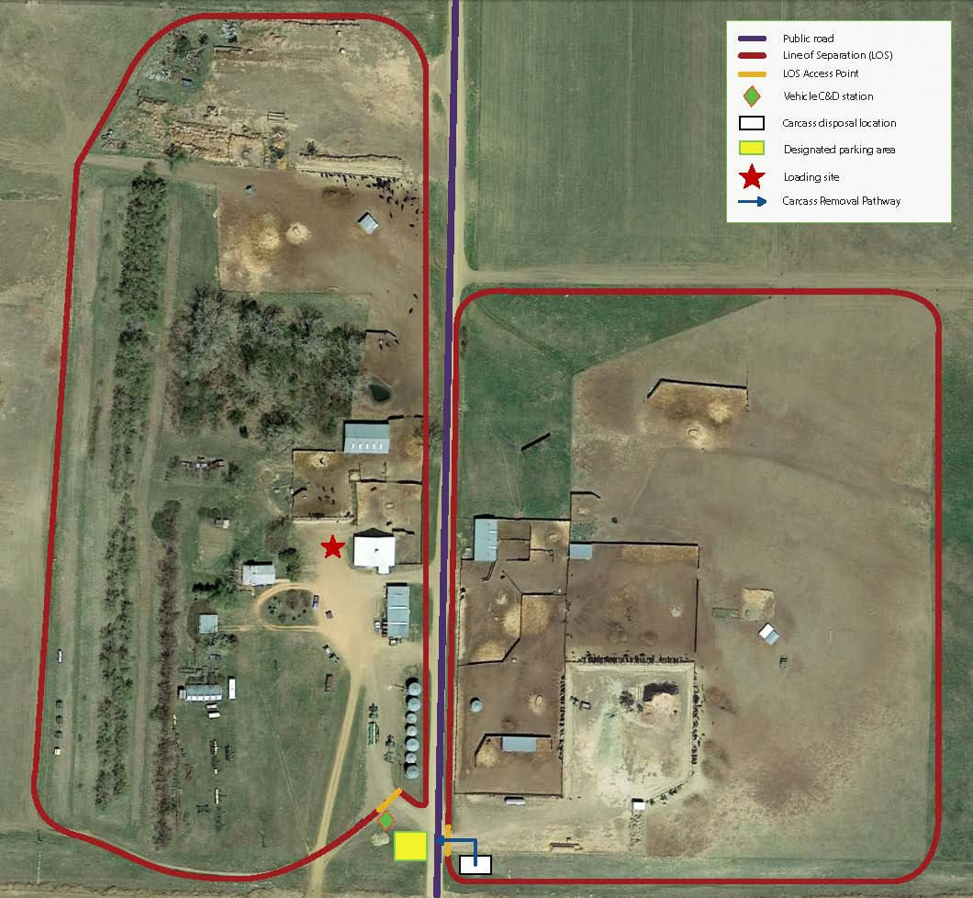
EXAMPLE: Replace with your operation’s premises map

